Data Structure and Algorithm

Laboratory Activity No. 6

Singly Linked Lists

|  |  |
| --- | --- |
| *Submitted by:* | *Instructor:* |
| Aquino, Jester J. | Engr. Maria Rizette H. Sayo |

August 23, 2025

# Objectives

Introduction

A linked list is an organization of a list where each item in the list is in a separate node. Linked lists look like the links in a chain. Each link is attached to the next link by a reference that points to the next link in the chain. When working with a linked list, each link in the chain is called a Node. Each node consists of two pieces of information, an item, which is the data associated with the node, and a link to the next node in the linked list, often called next.

This laboratory activity aims to implement the principles and techniques in:

* Writing algorithms using Linked list
* Writing a python program that will perform the common operations in a singly linked list

# Methods

* Write a Python program to create a singly linked list of prime numbers less than 20. By iterating through the list, display all the prime numbers, the head, and the tail of the list. (using Google Colab)
* Save your source codes to GitHub

# Results

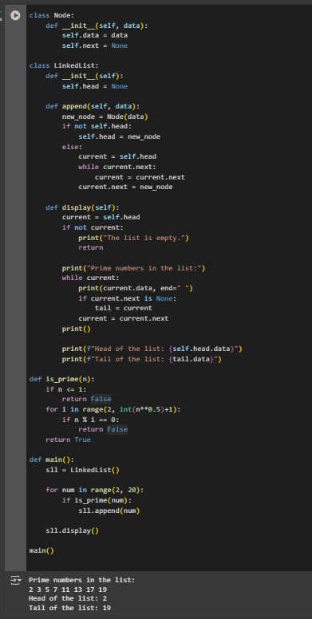

Figure 1 Screenshot of program

So, in this picture I use class node, so the object represents one element in linked list and next I use another class which is linkedlist to like appending data and displaying the list and printing the head and tails also the prime numbers in the list or range that are less than 20. After that I add define if the n is true, it means it’s a prime number if false it means it does not prime numbers.

# Conclusion

This program it demonstrates the singly linked list to store or display a prime numbers from less than 20.

**References**

Goodrich, M. T., Tamassia, R., & Goldwasser, M. H. (2013).

Data Structures and Algorithms in Python (1st ed.). Wiley.